## Smart public restroom

Ganesh college of Engineering , Salem

Submitted by ,

T. Gopika

G. subasri

K. Anusha

Y. Esther

SMART TOILET

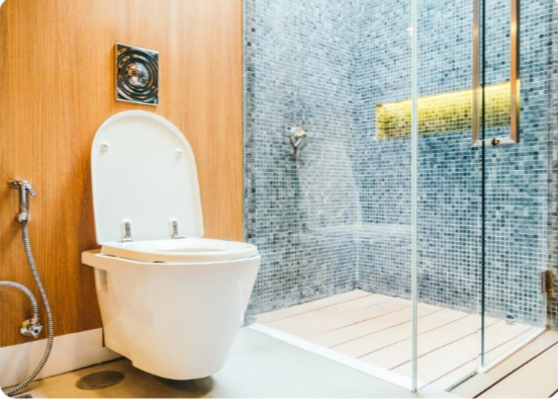

* + An intelligent toilet or smart toilet is a bathroom plumbing fixture or type of electronic bidet toilet which incorporate traditional bidet cleaning with the added enhancement of model SMART home technology.
  + A Smart toilet seat that measures blood pressure, weight , pulse and oxygen levels .
  + Intelligent toilet bidet function are managed through voice command , mobile app or remote control navigation depending on the toilets manufacture , make and model .

FEATURES

* Electronic bidet shower for front and rear cleansing.
* Seat – warming
* Adjustable water temperature
* Deodorizer
* Air dryer
* Many models offer water – conservative 1.0-1.28GPF

Five reasons to upgrade to a smart toilet

1.Advanced flush options

Smart toilet flush without

You having to flush them. Today smart toilet are outfitted with sensors that activate the flushing mechanism .

It senses the distance of your body and flushes automatically.

You can wave a hand in front of the toilet

2.THEY’RE OVERFLOW- PROOF

Virtually everyone has experienced at least one toilet overflow in their lives and everyone knows , it is bad news . Fortunately , smart toilet have addressed this issue .

3. Save water

Smart devices do much more than just make your life easier – they also help you reduce your carbon footprint and cut down on the amount of resources you use .

Smart toilet specifically , are great at saving water and electricity .

On their smaller flushes, they only use about 0.6 gallons per flush.

4.They’ve got a ton of features

They are lots of ways to upgrade your bathroom, you could invest in a bidet ,a heated toilet seat.

Here are a few of the feature ,

* Bidet sprayers and customizable
* Heated air dry feature
* Customizable , heated seat
* A foot warmer
* Automation flushing features
* Remote control

5.SMART TOILETS MODERNIZE YOUR HOME

Smart toilet , regardless of which make and model you purchase ,are modern,

Sleek, luxurious, and exciting to use.

<!DOCTYPE html>

<html>

<head>

<style>

.toilet {

width: 100px;

height: 150px;

background- color: white;

border: 2px solid black;

position: relative;

}

.flush {

width: 50px;

height: 50px;

background- color: blue;

position: absolute;

bottom: 0;

left: 25px;

display: none;

}

</style>

</head>

<body>

<div class="toilet" id="toilet">

<div class="flush" id="flush"></div>

</div>

<button onclick="flushToilet()">Flush</button>

<script>

function flush Toilet() {

const flushButton = document.getElementById('flush');

flushButton.style.display = 'block';

setTimeout(function() {

flushButton.style.display = 'none';

}, 2000); // Hide flush after 2 seconds (simulating flushing)

}

</script>

</body>

OUTPUT

</html> ] node "c:\Users\home\Documents\Untitled-2.js"

'node' is not recognized as an internal or external command,

operable program or batch file.

[Done] exited with code=1 in 0.296 seconds

By vs code

AUTOMATED TISSUE DISPENSER

A container package device or vending machine for holding and dispensing something is small amount as facial tissue,

Paper cups or candy.’

Work models of tissue dispenser

* A limit abutment carried by the strap in a position intersecting the excursion path of the finger the excursion path of the finger when the strap is in the second position.
* The machine has many features that will help it work efficient.
* It has two meter buffer convey or belt for the raw paper and servo motor to control by servomotor will automatically cut the film after it has cut the paper.

USES

* Reduced paper towel consumption :

Unlike manual dispensers which often leads to users pulling out more towels than necessary automatic versions dispense a pre determined length of paper towels this not only reduce the amount of paper consumed per user but also minimizes overall waste leading to cost savings in long term.

* Improved restroom cleanliness:

Automatic paper towel dispensers go beyond mere cost effectiveness they are pivotal in maintaining a high level of hygiene within your restrooms.

* 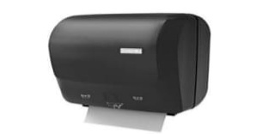
* Improve restroom cleanliness:

Automatic paper towel dispensers go beyond mere cost effectiveness they are pivotal in maintaining a high level of hygiene within your restrooms.

LEAKAGE DETECTOR

Water leaks and flooding can come from various sources –frozen pipe bursts, clogged drains ,malfunctioning air conditioning units , groundwater, storm water ,plumbing and fixtures, server cooling system ,and many more.

water leaks sensors can help you keep uptime high by sending alerts about leaks before happens. 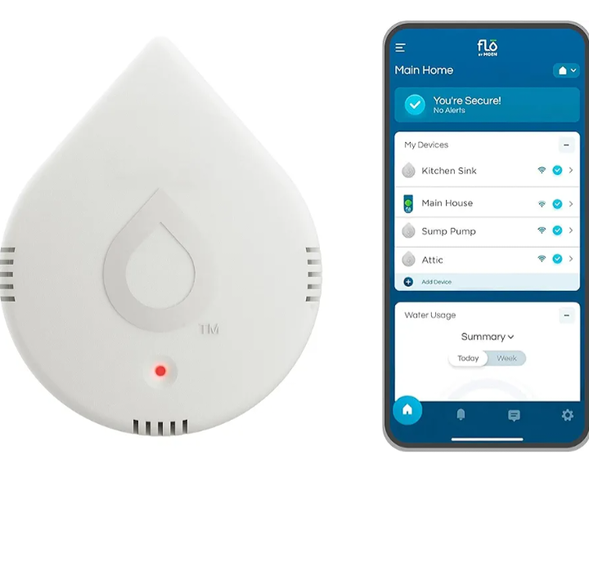

* **24/7 Real-time alerts :** when water excess humidity, or extreme temperature are detected, the device sends an alerts via the flo by Moen app , sounds an audible alarm, and emits a blinking LED light.
* **App monitoring and alerts :** Detectors notify homeowners of moisture through notifications to their smart phone and provide 24/7 monitoring.
* **Smart water network:** the way in providing peace of mind , personalization, comfort and control through the whole-home smart water ecosystem. <!DOCTYPE html>

<html>

<head>

<title>Smart Restroom Water Leakage Detector</title>

</head>

<body>

<h1>Smart Restroom Water Leakage Detector</h1>

<p>Status: <span id="status">Idle</span></p>

<button onclick="simulateLeak()">Simulate Leak</button>

<script>

function simulateLeak() {

const status = document.getElementById('status');

status.innerText = "Detecting leakage...";

// Simulating a delay for detection

setTimeout(function() {

// Simulate that a leak is detected

status.innerText = "Leak detected! Notifying maintenance...";

// Here you might integrate code to send notifications to maintenance teams or other alerts.

}, 3000); // Simulate a 3-second delay for detection

}

**OUTPUT:**

[Running] node "c:\Users\home\Documents\Untitled-2.js"

'node' is not recognized as an internal or external command,

operable program or batch file.

[Done] exited with code=1 in 0.296 seconds

[Running] node "c:\Users\home\Documents\Untitled-2.js"

'node' is not recognized as an internal or external command,

operable program or batch file.

[Done] exited with code=1 in 0.649 seconds

**Ref: VS code**

**AIR QUALITY MONITOR**

An important tool for improving air quality, protecting public health, and ensuring compliance with regulations.

**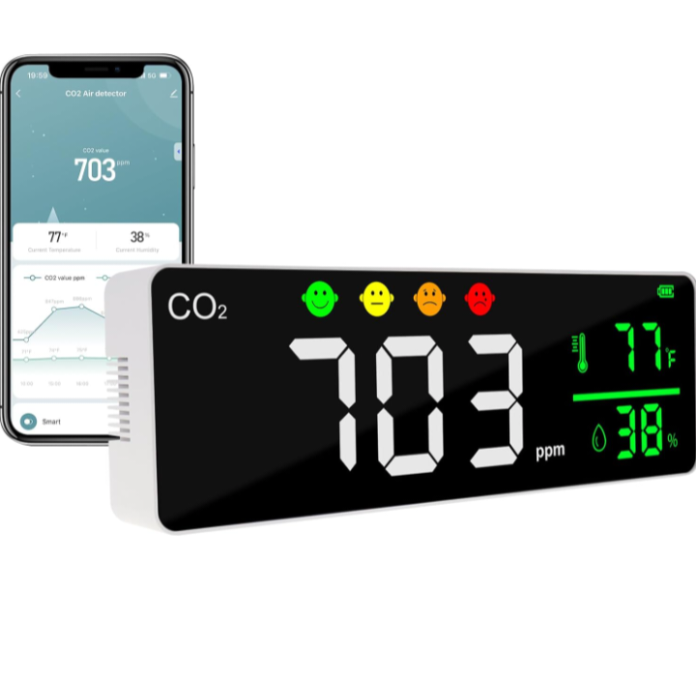  
 wifi CO2** detector air quality monitor carbon dioxide , temperature and humidity meter NDIR sensors for grow tent ,mushroom ,home, bedroom, car, wine cellars.

**CO2 FEATURE**

* Large LED screen
* Real time measurement
* Co2 audio and visual alarm
* Adjustable LED brightness
* Wifi mobile application
* CO2 range: 400-5000ppm
* Temperature range: 10-50 degree C
* Humidity range : 20- 85% RH

**CO2 INDICATOR**

* The good CO2 degree is 400ppm to 1000ppm
* The normal Co2 degree is 1001 ppm to 2000ppm
* The unhealthy Co2 degree is 2001 ppm to 3000ppm
* The dangerous Co2 degree is 3001 ppm to 5000ppm

**24 HOURS ONLINE MONITORING**

* Compatible with IOS and Android
* Audio and visual alarm will alarm when the reading value is above the alarm threshold.
* Co2 meter can hang on the wall or stand on the desk .

**AUTOMATION SANITIZER MACHINE**

The automation hand sanitizer machine ensure minimal or no contact at all. Usually, it is inbuilt with a photo-sensor .

Working operation

When hands place close to the sensor, it senses the motion . the variation triggers the solenoid valve, and fixed quantity of the liquid comes out .

The users hands are placed under the nozzle and before the sensor. The activated sensor will further activate a pump that dispenses a specific amount of sanitizer from the nozzle .

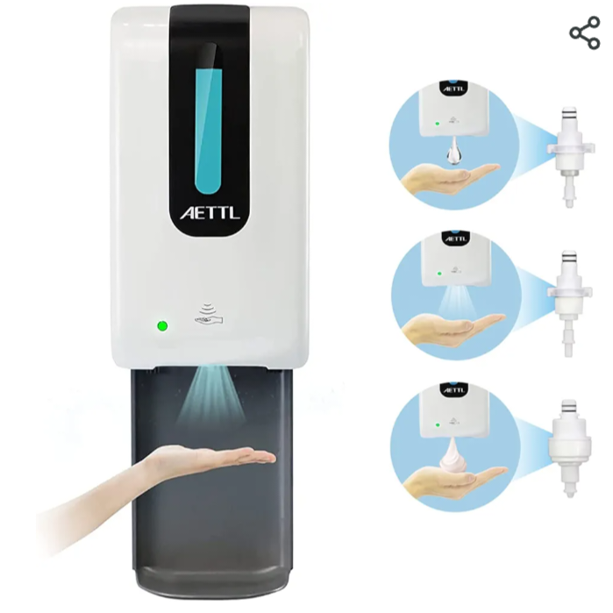

**USES**

To Ensure that people are prevented from being infected by contagious germs .

It can be placed at the entrance of a shop or home to make sure that visitors first sanitize their hands before entering the space.

**3 in 1 Stand Hand Sanitizer Dispenser**

* This Dispenser has 3 pump head could compatible with any hand sanitizer liquid Spray Pump for alcohol sanitizer built-in product, Drip Pump for gel liquid, Foam Pump for foam soap liquid in the package.
* GEL liquid dispenser use Drip pump
* Alcohol liquid dispenser use Spray pump
* Foam liquid dispenser use foam pump. **<!DOCTYPE html>**

**<html>**

**<head>**

**<title>Smart Restroom Sanitizer Dispenser</title>**

**<style>**

**/* Style the button */**

**#sanitizerButton {**

**padding: 10px 20px;**

**font-size: 16px;**

**}**

**</style>**

**</head>**

**<body>**

**<h1>Welcome to the Smart Restroom</h1>**

**<button id="sanitizerButton">Press for Sanitizer</button>**

**<script>**

**// Function to dispense sanitizer**

**function dispenseSanitizer() {**

**console.log("Sanitizer Dispensed!"); // Simulate sanitizer dispensing**

**// You would connect this function to actual hardware for dispenser activation**

**}**

**// Event listener for the button click**

**document.getElementById('sanitizerButton').addEventListener('click', function() {**

**Dispense Sanitizer(); // Call the dispense Sanitizer function on button click**

**});**

**</script>**

**</body>**

**</html>**node "C:\Users\home\AppData\Local\Temp\tempCodeRunnerFile.javascript"

'node' is not recognized as an internal or external command,

operable program or batch file.

[Done] exited with code=1 in 9.399 seconds

**ADVANTAGE OF SMART TOILETS**

* Enhanced Hygiene
* Personalized Comfort
* Water Efficiency
* **Health Monitoring**
* **Energy Efficiency**
* Enhanced Convenience
* Integrated Technology

**DISADVANTAGES OF SMART PUBLIC TOILET**

* Smart toilets are more expensive
* Smart toilets can be complex to install and use
* It may require specialized repairs and maintains it can be costly
* Customization options may be limited compared to traditional toile